SILVER OAK UNIVERSITY

TUTORIAL – 12

AI-POWERED SOFTWARE TESTING

Aim

To analyze AI-powered software testing tools and apply Generative AI techniques for test case generation, test data creation, defect prediction, requirement analysis, and automated Selenium test script generation for Software Quality Assurance.

Description

Generative AI can assist software testers in analyzing requirements and generating test scenarios, test cases, test data, and automation scripts. AI-generated output must be reviewed and corrected before execution.

Problem Statement

A registered user should be able to log in using a valid username and password. Invalid credentials should be rejected, and an appropriate error message should be displayed.

Generative AI techniques are used to analyze the requirements, generate positive and negative test cases, prepare test data, and identify possible defect-prone areas.

Implementation Details

Project Name: AI-Powered Software Testing

Application Name: SauceDemo

Module Name: Login and Authentication

SDLC Model: Agile

Programming Language: Python

IDE Used: PyCharm

Automation Tool: Selenium WebDriver

Browser: Google Chrome

Website URL: https://www.saucedemo.com/

Requirement Analysis

The login functionality should allow registered users to access the application using valid credentials. The system should reject invalid credentials and display an appropriate error message.

The following functional requirements are considered:

1. The login page should display username and password fields.
2. The login page should contain a Login button.
3. Valid credentials should open the Products page.
4. Invalid credentials should display an error message.
5. Empty login fields should be validated.
6. The system should not allow login with incorrect credentials.

AI-Generated Test Scenarios

Positive Test Scenario:

Enter a valid username and password and verify that the user can successfully log in.

Negative Test Scenario 1:

Enter an invalid username and password and verify that an error message appears.

Negative Test Scenario 2:

Enter a valid username with an incorrect password and verify that login is rejected.

Validation Test Scenario:

Leave the username and password fields empty and click the Login button. Verify that a validation message appears.

Test Data

Valid Username: standard_user

Valid Password: secret_sauce

Invalid Username: invalid_user

Invalid Password: wrong_password

Empty Input: Username and password left blank.

Automation Test Case Details

Test Case 1: Valid Login

Test Case ID: TC-12-01

Objective: To verify that a user can log in using valid credentials.

Test Procedure:

1. Open the SauceDemo website.
2. Enter the valid username.
3. Enter the valid password.
4. Click the Login button.

Expected Result: The Products page should be displayed.

Actual Result: pass

Status:pass

Screenshot: [Insert Screenshot of Successful Login Here]
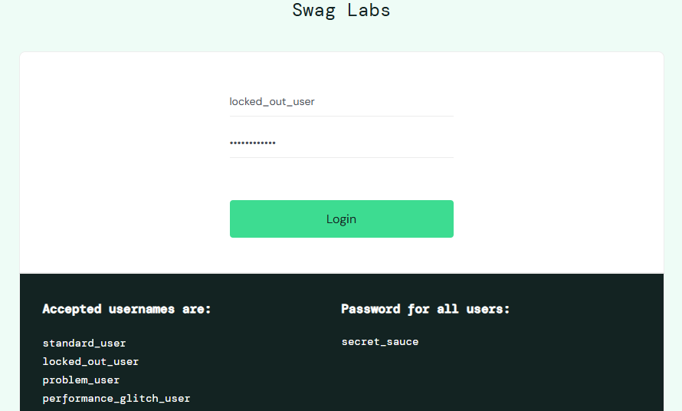

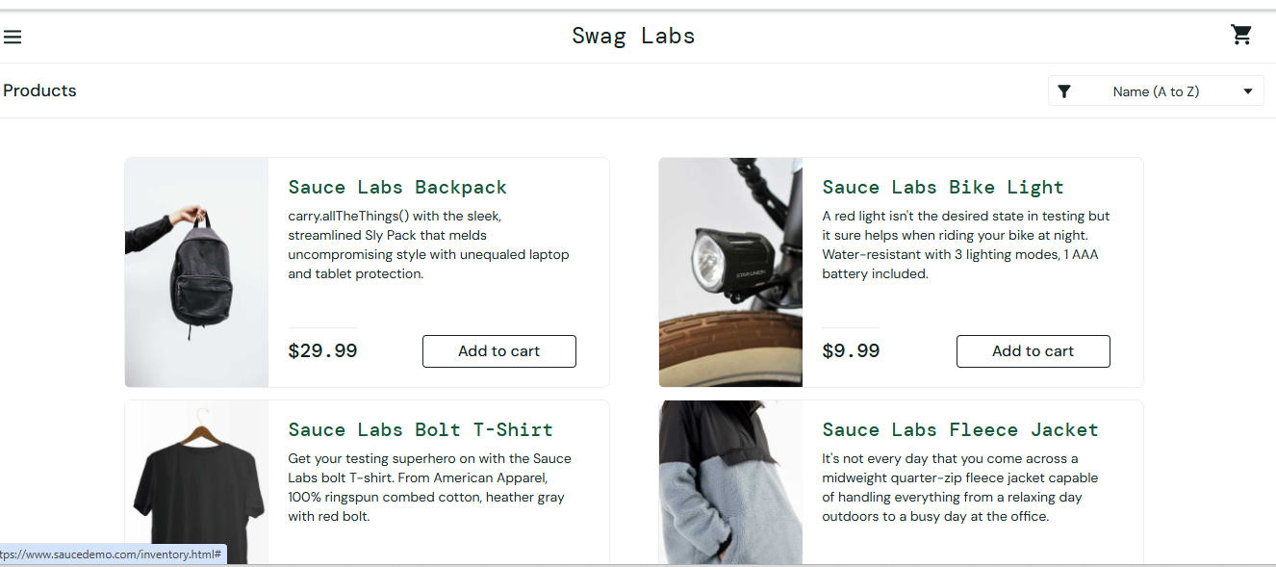

Test Case 2: Invalid Credentials

Test Case ID: TC-12-02

Objective: To verify that the system rejects invalid credentials.

Test Procedure:

1. Open the SauceDemo website.
2. Enter an invalid username.
3. Enter an incorrect password.
4. Click the Login button.

Expected Result: An error message should appear, and login should be rejected.

Actual Result: pass

Status: pass

Screenshot: [Insert Screenshot of Invalid Credentials Here]
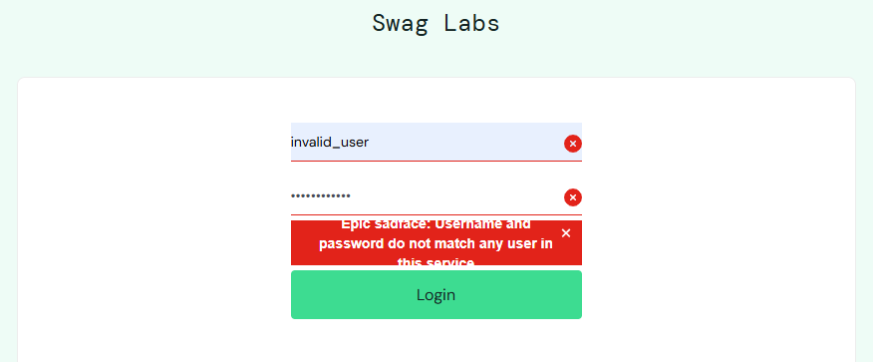

Test Case 3: Incorrect Password

Test Case ID: TC-12-03

Objective: To verify that login is rejected when the password is incorrect.

Test Procedure:

1. Open the SauceDemo website.
2. Enter the valid username.
3. Enter an incorrect password.
4. Click the Login button.

Expected Result: An error message should appear, and the user should remain on the login page.

Actual Result: pass
Status: pass

Screenshot: [Insert Screenshot of Incorrect Password Here]

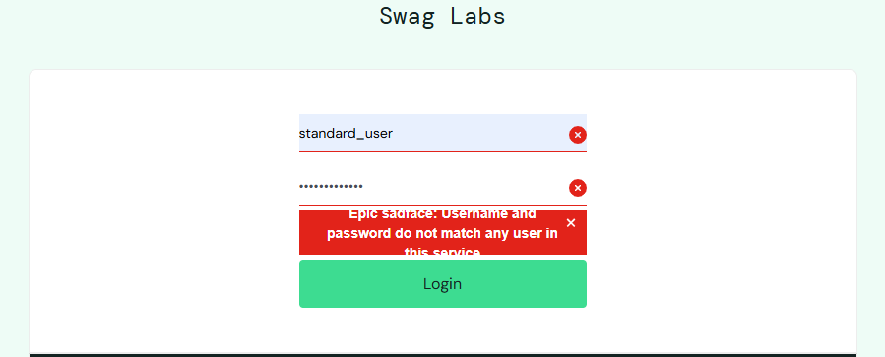

Test Case 4: Empty Login Fields

Test Case ID: TC-12-04

Objective: To verify that the application validates empty login fields.

Test Procedure:

1. Open the SauceDemo website.
2. Leave the username field empty.
3. Leave the password field empty.
4. Click the Login button.

Expected Result: A validation message should appear asking for the required username.

Actual Result: pass

Status: pass

Screenshot: [Insert Screenshot of Empty Fields Validation Here]

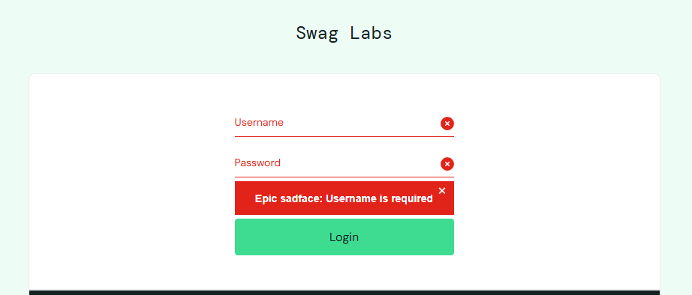

Automation Test Execution

The automation test is performed using Python and Selenium WebDriver.

Steps:

1. Open the SauceDemo website in Google Chrome.
2. Enter valid login credentials.
3. Click the Login button and verify the Products page.
4. Return to the login page.
5. Enter invalid credentials and verify the error message.
6. Test an incorrect password.
7. Test empty username and password fields.
8. Record the actual results and test status.

Screenshot: [Insert Screenshot of PyCharm Execution Output Here]

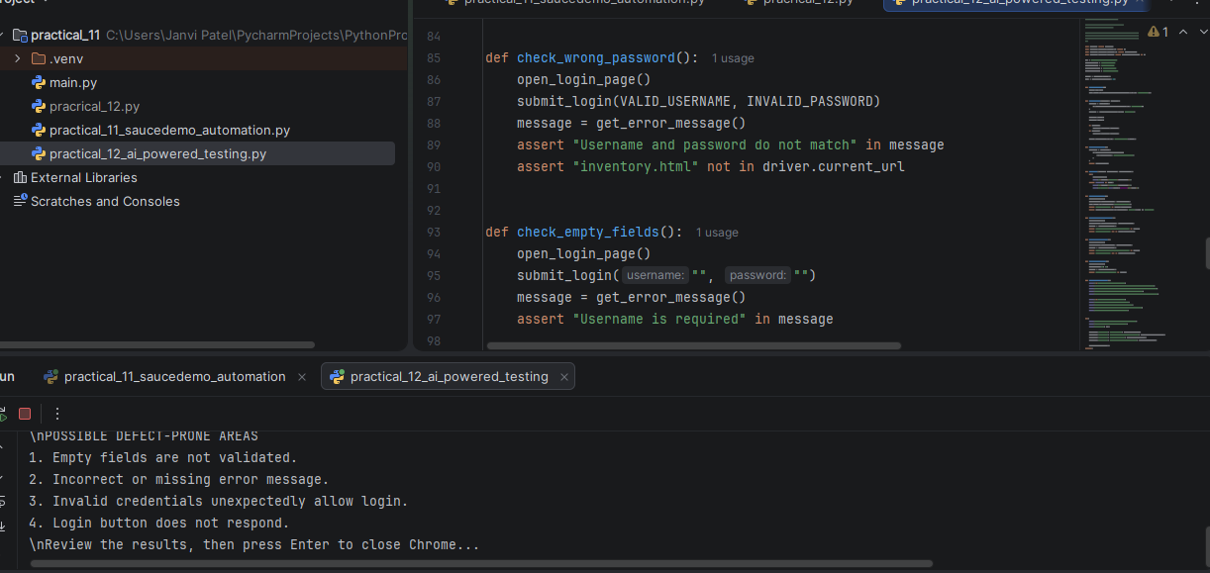

Regression Test Execution Report

RT-01: Valid Login

Expected Result: Products page should be displayed.

Actual Result: pass

Status: pass

RT-02: Invalid Credentials

Expected Result: Error message should be displayed.

Actual Result: pass

Status: pass

RT-03: Incorrect Password

Expected Result: Login should be rejected.

Actual Result: pass

Status: pass

RT-04: Empty Fields

Expected Result: Validation message should be displayed.

Actual Result: pass

Status: pass

Possible Defect-Prone Areas

1. Missing validation when the username or password is empty.
2. Incorrect error message for invalid credentials.
3. Login succeeding with invalid credentials.
4. Login button not responding.
5. Error message not being displayed correctly.
6. Incorrect handling of invalid login data.

Observation

The login requirements were analyzed, and positive and negative test cases were prepared. Test data was created for valid credentials, invalid credentials, incorrect passwords, and empty fields.

Selenium WebDriver was used to automate the login tests. The actual observations and Pass/Fail status should be recorded after executing the script.

Result

AI-assisted test scenarios and test data were prepared, and a Selenium automation script was created for the SauceDemo Login and Authentication module.

The final test results are recorded after executing the test script.

Conclusion

Generative AI can assist software testers in analyzing requirements, generating test cases, preparing test data, creating automation-script ideas, and identifying possible defect-prone areas.

However, AI-generated test cases and scripts must be reviewed, and actual execution is necessary to verify the results.

Precautions

1. Install Selenium in the same Python environment used by PyCharm.
2. Verify the website URL and test data before execution.
3. Record actual results only after running the tests.
4. Mark a test as Pass only when the actual result matches the expected result.
5. Review AI-generated suggestions before using them.

